 | 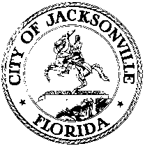
 | OFFICE OF THE CITY COUNCIL
ANNA LOPEZ BROSCHE  PRESIDENT  JACKSONVILLE CITY COUNCIL  OFFICE (904) 630-1452 |  | SUITE 425, CITY HALL  117 WEST DUVAL STREET  JACKSONVILLE, FLORIDA  32202
TASK FORCE ON OPEN GOVERNMENT
AGENDA
June 27, 2018
Lynwood Roberts Room
1:00 pm

Introductions

Discussion
Final Report

Public Comment

Chairs: Hank Coxe and Dr. Sherry Magill
Members: Ywana Allen
Rachael Fortune
The Honorable Alberta Hipps
Ron Littlepage
Michael Lockamy
Audrey Moran
The Honorable Jim Overton
Sabeen Perwaiz
Cleve Warren-EXCUSED

The is the final Task Force on Open Government meeting.

